**WEEK-3**

**Exercise 1: Configuring a Basic Spring Application**

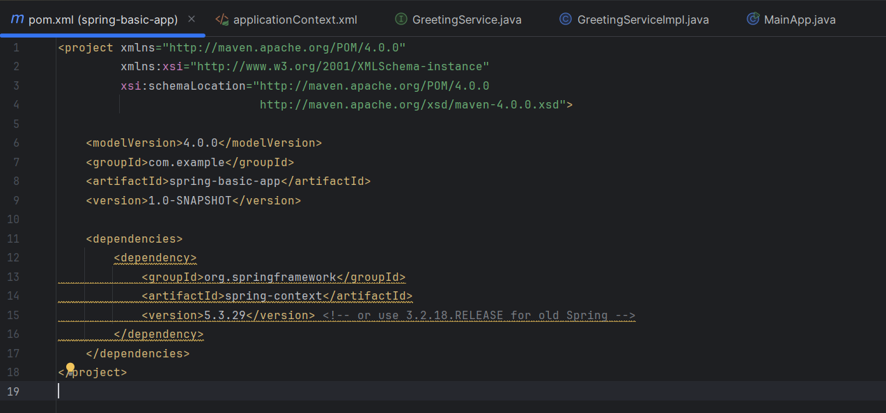

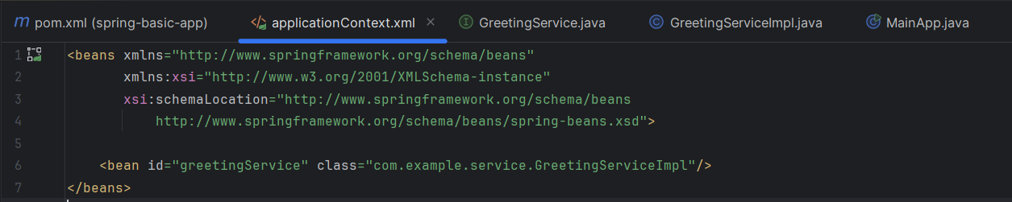

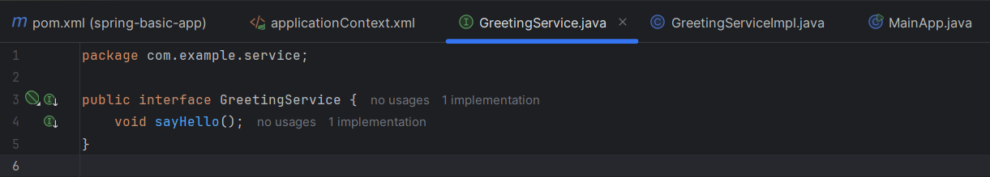

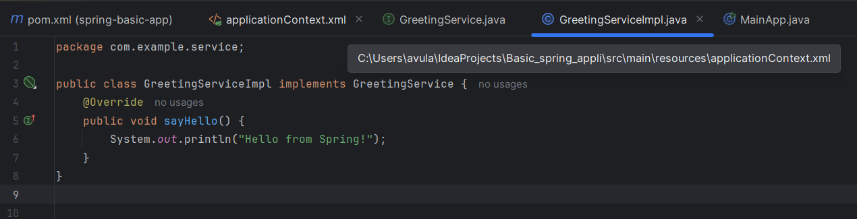

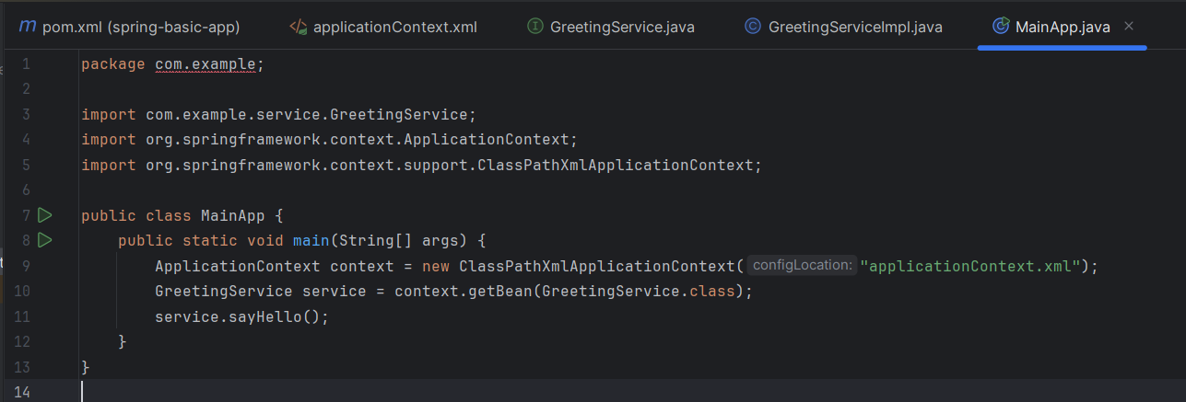

OUTPUT:

